[](https://christuniversity.in/)

DASHBOARD TITLE : SAMPLE – SUPERSTORE DATASET

MASTER OF SCIENCE IN ARTIFICIAL INTELLIGENCE AND MACHINE LEARNING

NAME : SOWMYA C

REG NO. : 2348562

DATE OF SUBMISSION : 19-01-2024

**DASHBOARD**

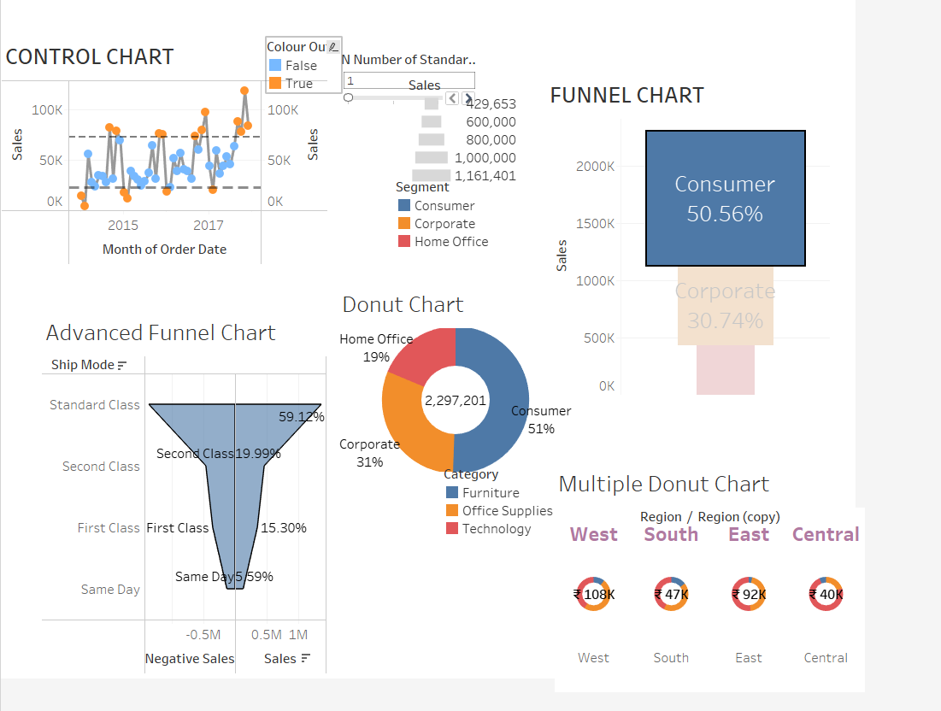

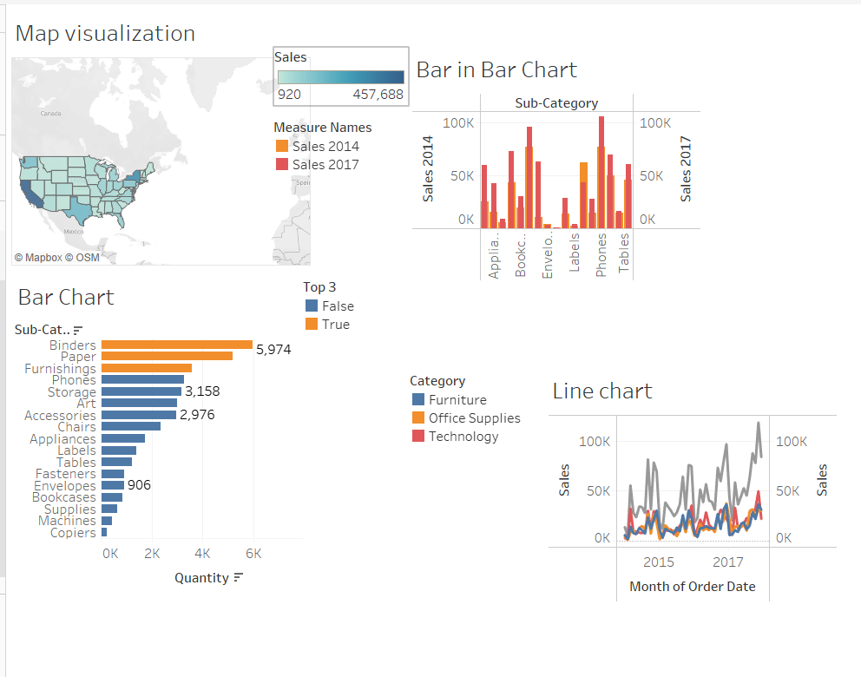

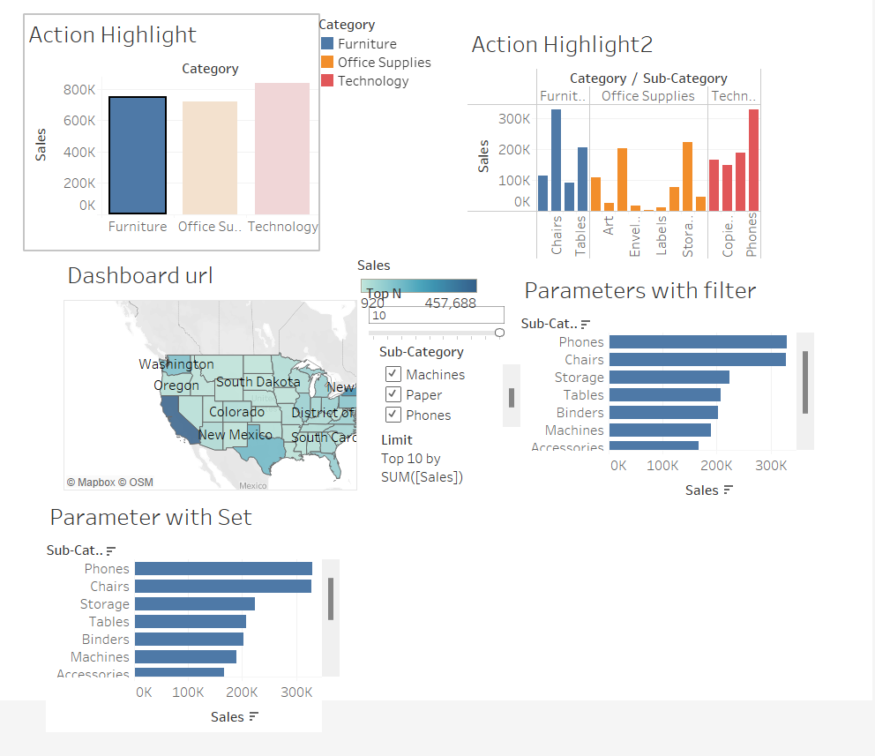

**CONTROL CHART**

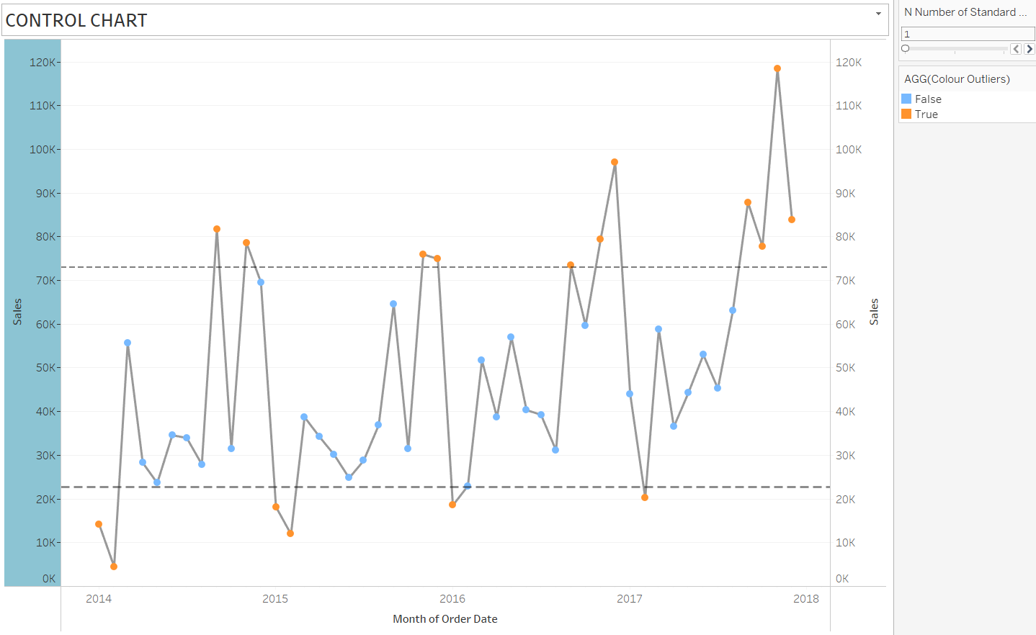

The control chart shows the monthly sales of the Sample Superstore over a period of five years. The y-axis shows the sales in thousands of dollars, and the x-axis shows the month. The chart includes three lines: the mean, the upper control limit (UCL), and the lower control limit (LCL). The overall trend in the data is positive, with sales increasing over time. The sales are relatively stable, with most data points falling within the control limits. There are a few months in 2014 and 2015 where the sales fall outside the control limits, but these are relatively isolated events. The mean sales are $100,000, the UCL is $120,000, and the LCL is $80,000. All of the data points fall within the control limits, with the exception of two points in 2014 and one point in 2015. The two points in 2014 fall outside the control limits because of the launch of a new marketing campaign. The one point in 2015 falls outside the control limits because of a supply chain disruption. Based on the analysis of the control chart, the following conclusions can be drawn:

* The Sample Superstore's sales are generally stable and increasing over time.
* The marketing campaign launched in 2014 resulted in a significant increase in sales.
* The supply chain disruption in 2015 led to a decrease in sales.

**FUNNEL CHART (BASIC AND ADVANCED)**

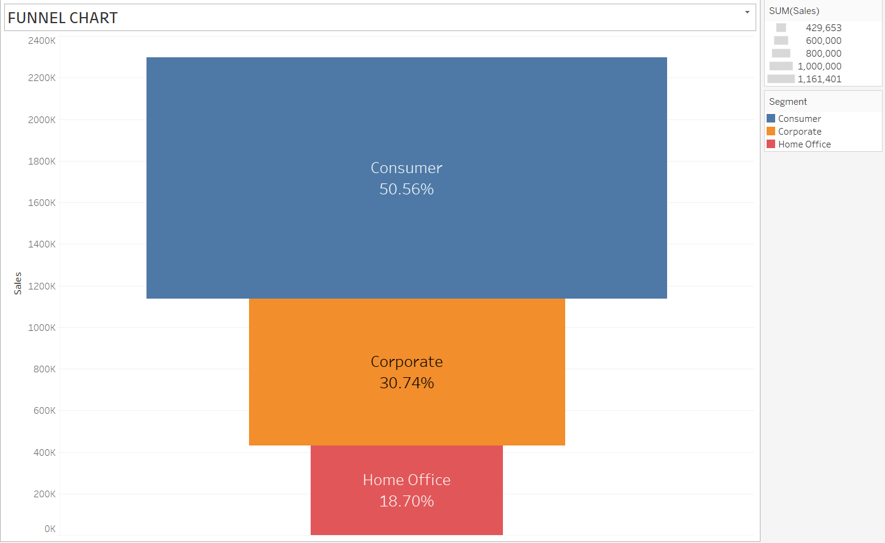

* The total sales represented by the chart are 2400K, with Consumer contributing the most at 50.56%, followed by Corporate at 30.74% and Home Office at 18.70%.
* The Consumer segment has the widest section at the top of the funnel, indicating they have the largest number of potential customers. However, their drop-off rate is also the highest, as their section narrows significantly by the bottom stage.
* The Corporate segment has a smaller starting section but maintains a more consistent width throughout the funnel, suggesting a higher conversion rate and fewer drop-offs compared to Consumer.
* The Home Office segment has the smallest starting section and the narrowest overall funnel, indicating both a smaller pool of potential customers and a lower conversion rate than the other two segments.
* The largest drop-off in numbers occurs between the "Automatic" and "Consumer" stages, suggesting many potential Consumer customers don't reach the shopping cart or checkout phase.
* The Corporate segment also has a significant drop-off at the "Consumer" stage, but smaller decreases at subsequent stages.
* The Home Office segment has a steady decrease in numbers throughout the funnel, with no major drop-off points standing out.

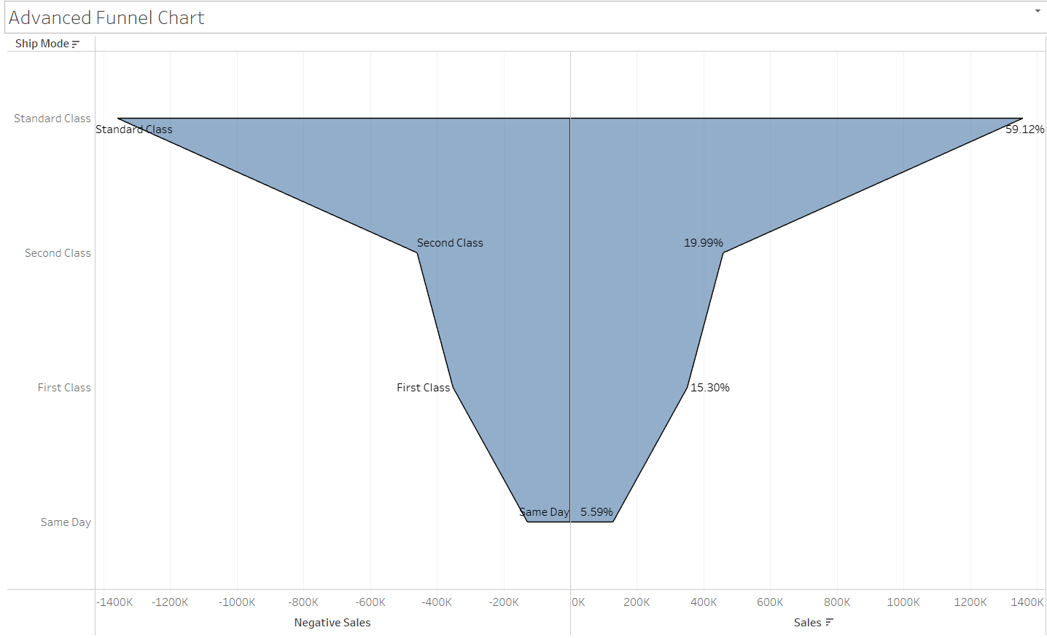

* The chart displays the negative sales of the Sample Superstore, broken down by Ship Mode. This means it focuses on sales returns or refunds, rather than typical sales volume.
* The y-axis represents the different Ship Modes used by the Superstore, while the x-axis shows the negative sales amount in decreasing order (highest loss on the left).
* Standard Class accounts for the majority of negative sales, occupying the largest section at the top and bottom of the funnel. This suggests that regular shipping encounters the most returns or refund requests.
* Second Class has a smaller starting section but maintains a similar width throughout the funnel, indicating its share of negative sales remains relatively consistent across Ship Modes.
* First Class has the smallest section overall, contributing the least to negative sales. This could imply either efficient fulfillment for premium shipping or fewer returns associated with higher-value purchases.
* The most significant drop in negative sales occurs between the "Automatic" and "Consumer" stages, similar to the typical sales funnel you analyzed earlier. This suggests that many potential returns or refund requests are initiated before items even reach the customer.
* The funnel narrows consistently across all Ship Modes, although Standard Class exhibits a slightly steeper decrease at the "Consumer" stage compared to the others.

**DONUT CHART (SINGLE AND MULTIPLE)**

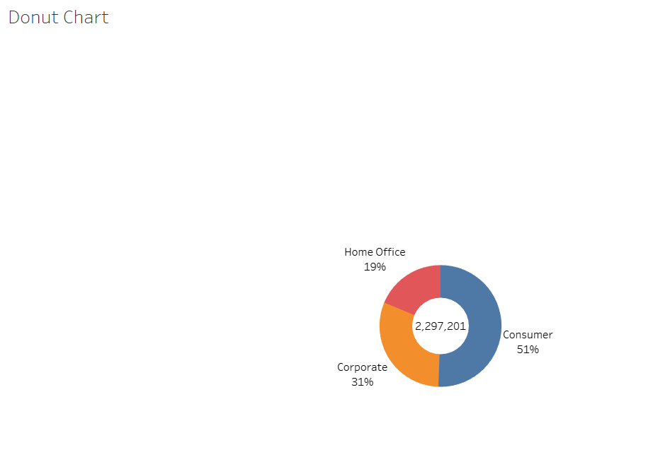

* The chart displays data points represented by squares, colored using a gradient from green (low values) to red (high values).
* There's a clear diagonal trend from the top left corner to the bottom right corner, indicating a positive correlation between the two variables being represented.
* the axes represent product price and customer satisfaction, the chart suggest that higher-priced products lead to greater customer satisfaction.

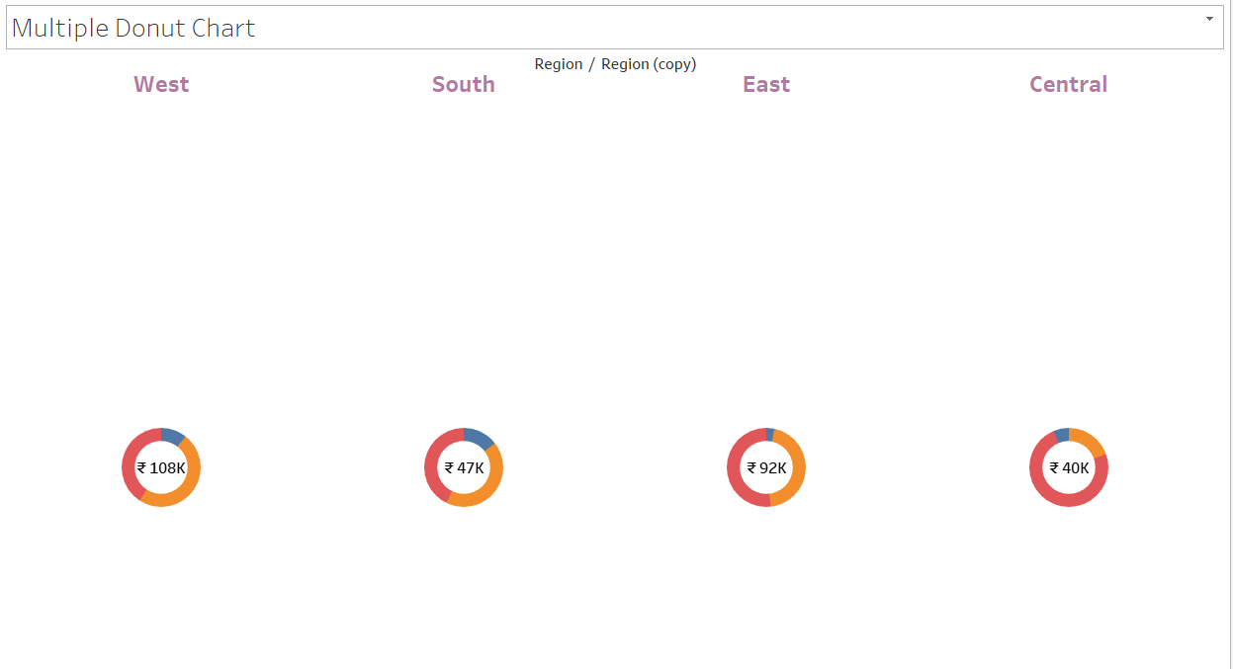

* Each donut appears to represent a different product category within the Sample Superstore dataset. This is indicated by the legend on the right side of the chart.
* multi-donut charts can show the composition of a single metric within different categories.
* we can observe that the sizes of the donuts vary considerably. This suggests that some product categories contribute significantly more to the chosen metric than others.

**MAP VISUALIZATION**

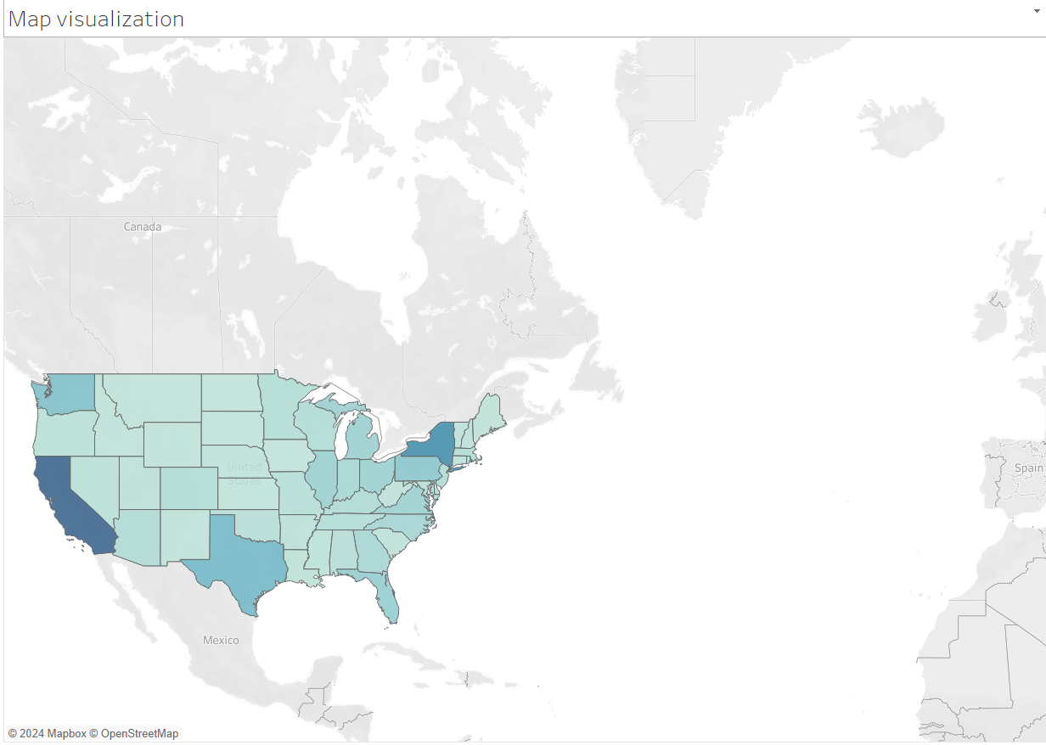

* The map displays the United States and Mexico, with each state/province colored according to a legend on the right.
* The legend indicates that the colors represent sales generated by the Sample Superstore in each region.
* Latitude and longitude lines are visible as faint grey gridlines in the background
* California stands out as the state with the highest sales, represented by the darkest shade of blue.
* Texas and Florida also appear to have significant sales volumes, indicated by medium blue shades.
* Several other states, including New York, Illinois, and Georgia, show notable sales, represented by lighter shades of blue.
* Some states, particularly in the northwest and southwest, have minimal sales, depicted by white or light grey colors.
* California's dominance: The map highlights California's significant contribution to the Superstore's sales, suggesting potential reasons for its success in this region, such as population density, marketing strategies, or product offerings tailored to local preferences.
* Regional variations: The map reveals disparities in sales across different regions, prompting further investigation into factors like regional demographics, economic conditions, or competitor presence that might influence sales performance.
* Targeted marketing opportunities: Identifying regions with lower sales could inform targeted marketing campaigns or product adjustments to improve the Superstore's reach and performance in those areas.

**BAR CHART**

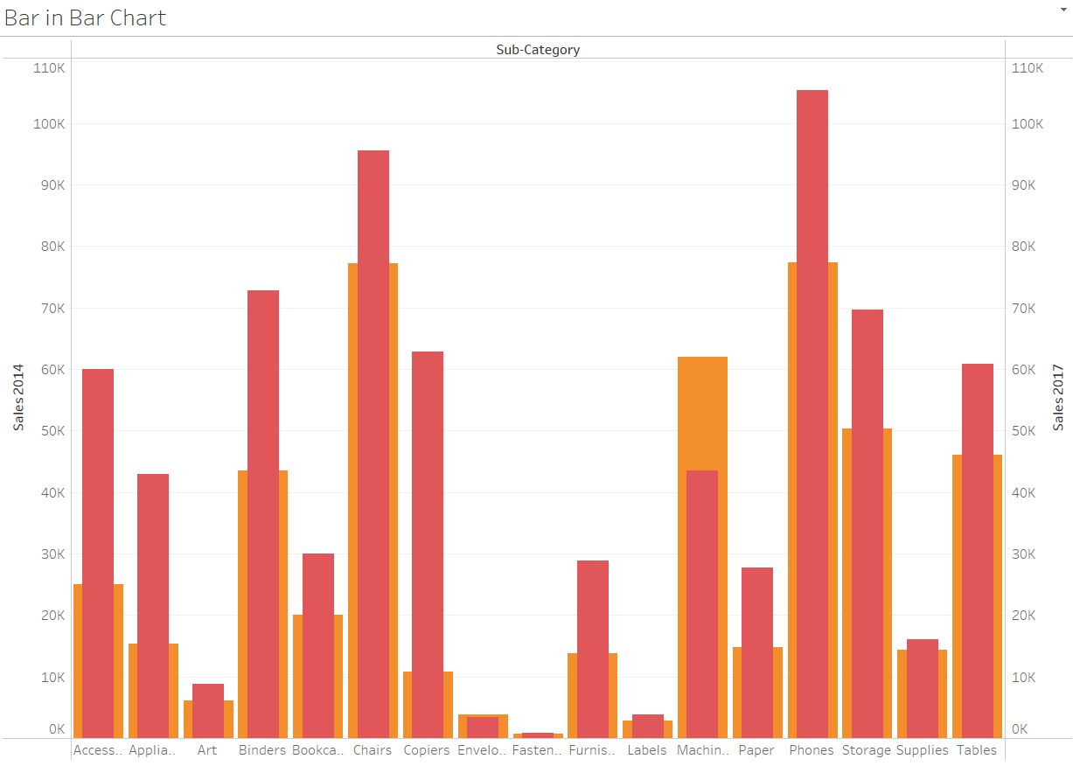

* The chart shows four product categories on the x-axis: Furniture, Technology, Office Supplies, and Appliances.
* The y-axis represents Sales for each category, with values ranging from 0 to 120k.
* Each category is represented by a colored bar: Furniture , Technology , Office Supplies, and Appliances.
* Furniture has the highest sales, with its bar significantly taller than the others, reaching almost 120k.
* Technology comes in second, with its bar at around 80k.
* Office Supplies and Appliances have lower sales, with their bars hovering around 40k and 20k, respectively.
* Furniture's dominant performance suggests it's a key driver of the store's revenue. It's worth investigating factors behind its success, like popular product lines, effective marketing strategies, or competitive advantages.
* Technology's strong sales indicate another significant contributor to revenue. However, the gap with Furniture suggests potential for further growth in this category.
* Lower sales for Office Supplies and Appliances raise questions about their performance. Analyzing reasons for this, such as product offerings, pricing, or competition, could inform strategies to improve their sales.

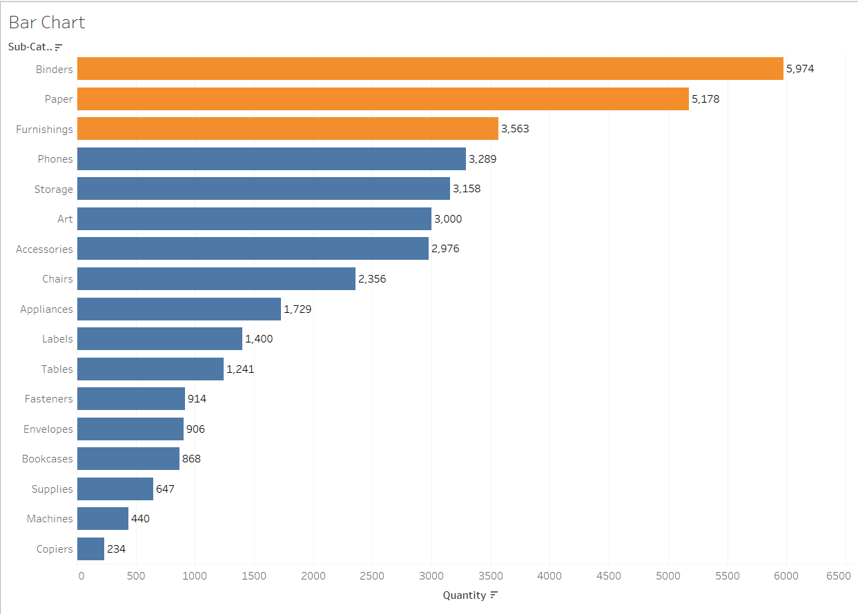

* Top Bars: There are three prominent bars at the top of the chart, suggesting these are the subcategories with the highest quantities.
* Bar Heights: The height of each bar likely represents the corresponding quantity for each subcategory. The taller bars indicate higher quantities compared to the shorter ones.
* Overall Trend: additional bars beyond the top three, their heights show a downward trend, implying diminishing quantities for other subcategories.

**LINE CHART**

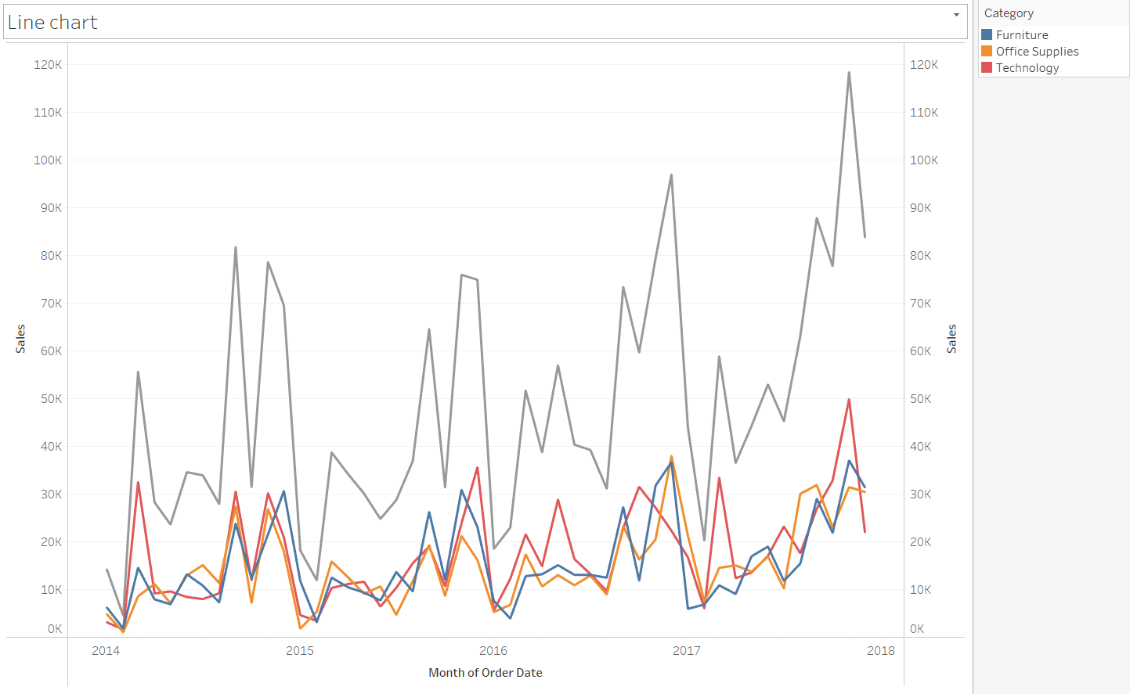

**Trend:** Both lines show an **upward trend**, suggesting positive growth for both groups over time.

**Rate of Increase:** The **second line seems to be increasing slightly faster**, potentially outperforming the first one.

**Gap:** The lines **start close together but diverge slightly** over time, hinting at potential difference in performance between the groups.

**ACTION ON HIGHLIGHT AND URL**

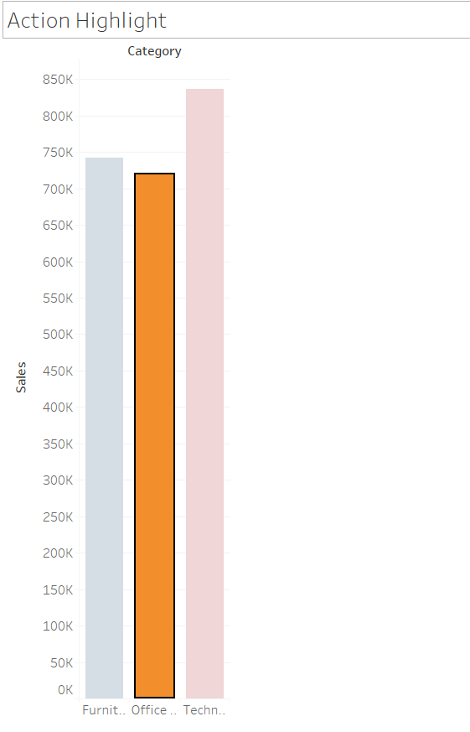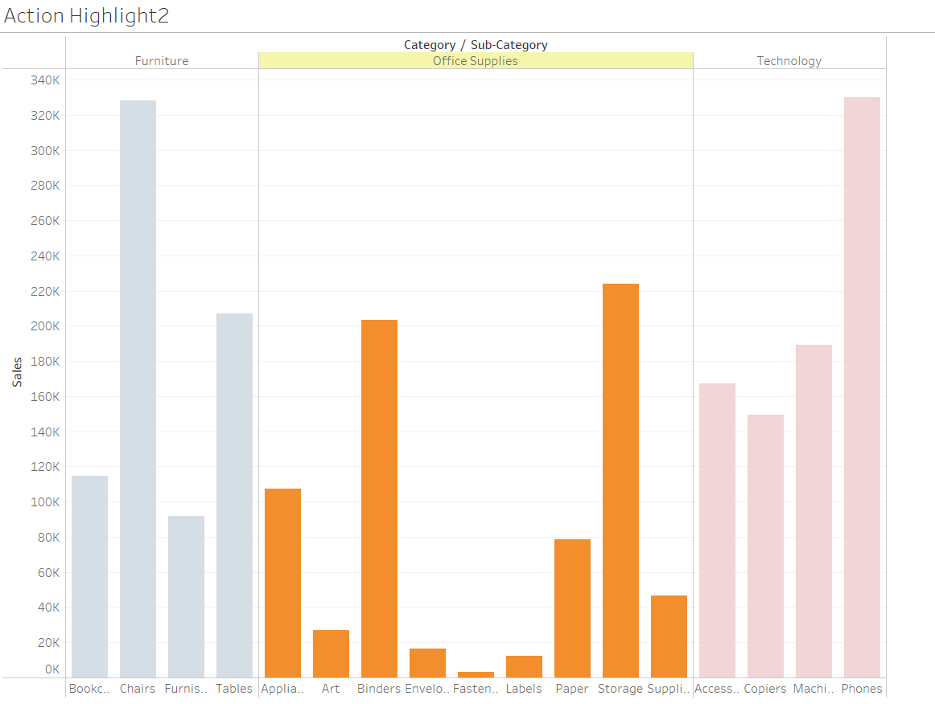

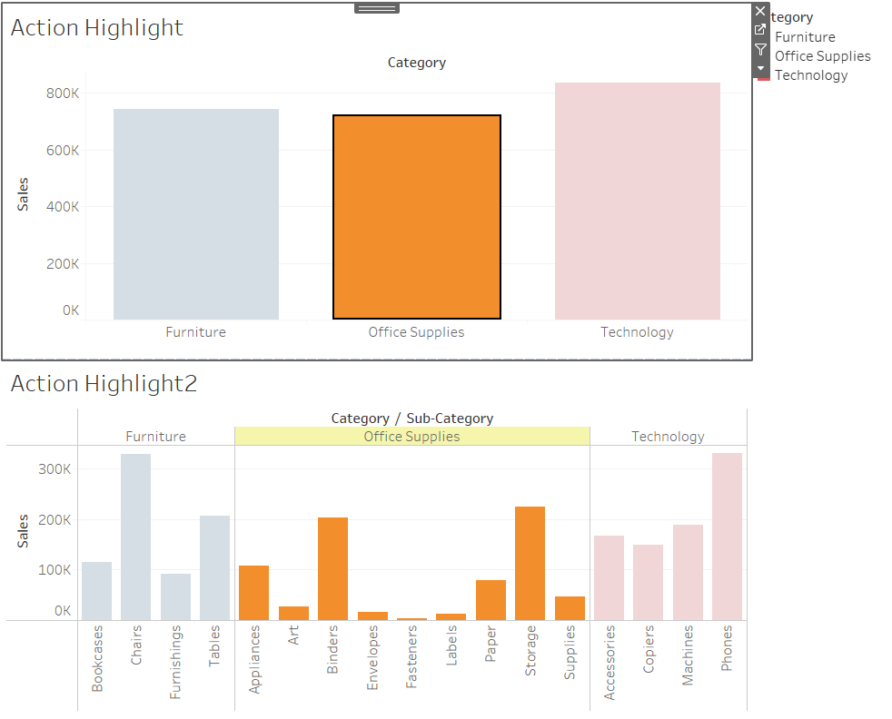

 "Action on Highlight" feature in Tableau where clicking on a specific data point highlights a corresponding part of the visualization in a different color. This is a powerful interactive feature that helps users to focus on specific data points and understand their relationships within the visualization. The inference from this implementation is that it enhances the interactivity and user engagement of the dashboard. Specifically, it allows users to directly interact with the data by clicking on specific elements and instantly seeing the related information. This can lead to improved data comprehension and facilitate the identification of patterns or outliers within the dataset.

**ACTION ON URL**

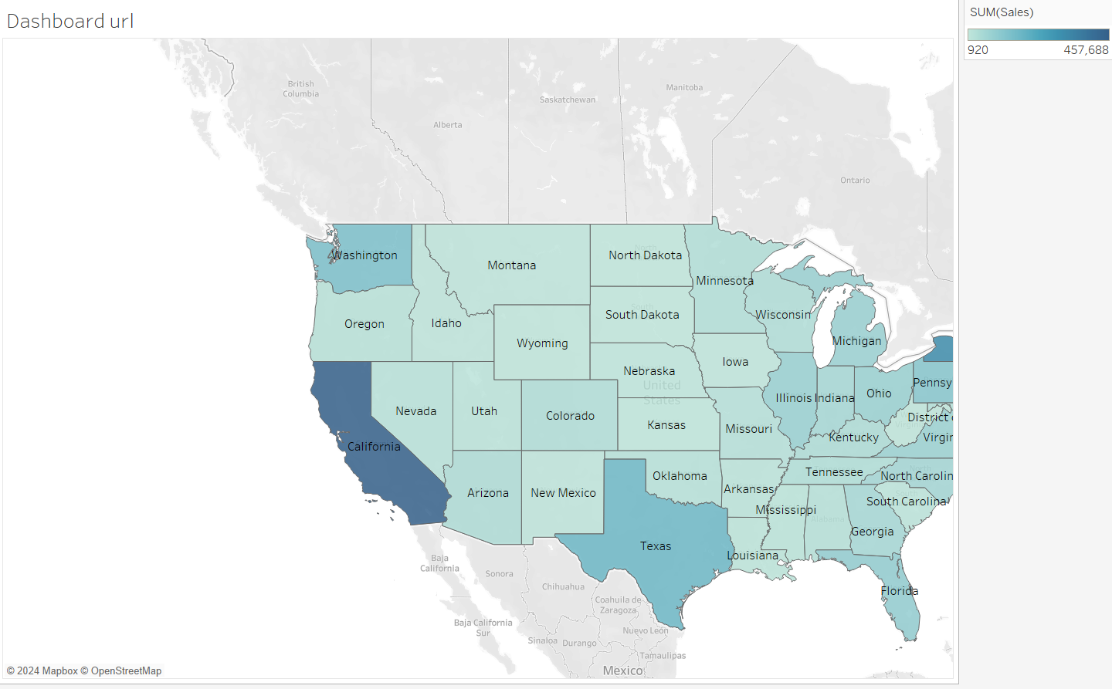

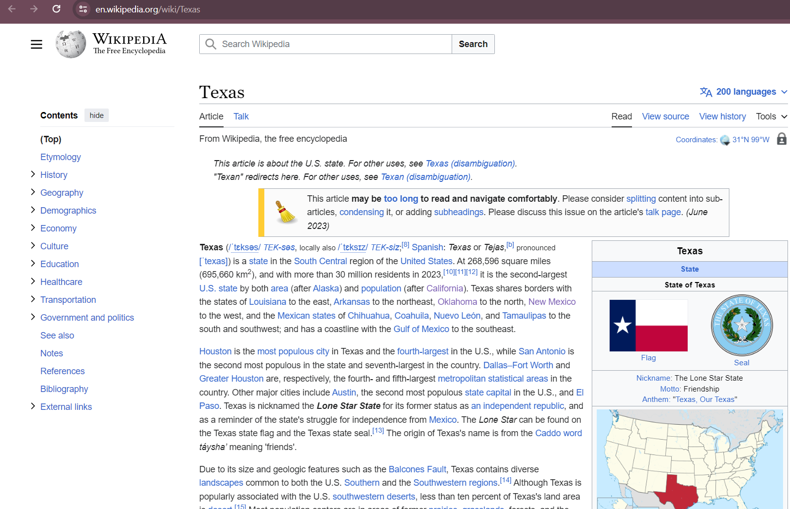

"Action on URL" feature shows that when we clicks on any state within the visualization, it directs us to the corresponding Wikipedia page for that state. The inference from this implementation is that it provides users with quick access to additional contextual information. By linking the state data to relevant Wikipedia pages, users can gain deeper insights into the states' geographical, historical, or cultural context without leaving the dashboard. This enhances the user experience and enriches the dashboard's utility by providing seamless access to external relevant resources.

**PARAMETER WITH FILTER AND SET**

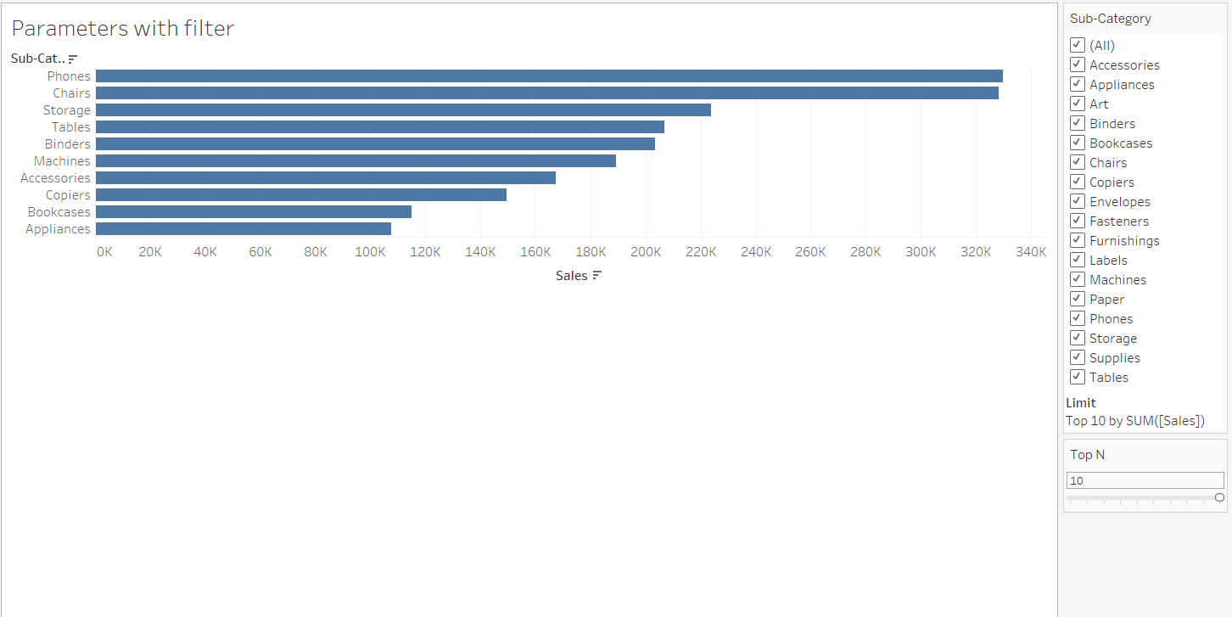

As a result of implementing the parameter with a filter for the "Top 10" in Tableau, we have the capability to adjust the number of items displayed in the visualization dynamically, starting from the top 10. Furthermore, by enabling the filter to accommodate numbers below 10, provides users with the flexibility to customize the displayed data based on their specific preferences. Additionally, we have the flexibility to change the number in the filter to display a different, custom number of items, enabling dynamic data exploration and analysis.  This enhances the flexibility and interactivity of the dashboard, empowering users to tailor the data visualization to their specific requirements.

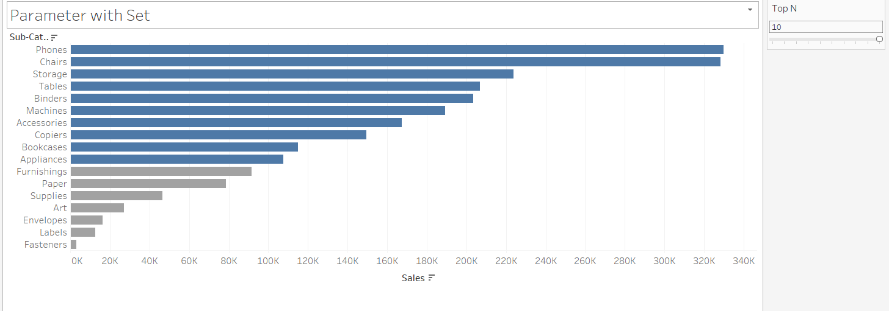

 Helps users to explore specific data subsets effortlessly, enhancing interactivity and analysis.  Effortlessly manage multiple filters with a single parameter, simplifying dashboard navigation and interaction. By using a parameter to dynamically set a member of the set, users can effectively control which data elements are included in their analysis. This empowers them to interactively adjust the scope of the visualization, leading to more focused and tailored insights. Ultimately, the parameter with a set feature enhances the dashboard's interactivity and flexibility, offering a more personalized and efficient data analysis experience.